MMCT-West Africa 2015 Lent prayer calendar
Themes move from a call we hear on Monday through relevant countries and activities, and end with Sunday praise.
Learn more about MMCT and this Lenten resource at PrayMMCT.wordpress.com.

Feb 18-22: mobile services
Feb 23-Mar 1: our team: valuing different languages and missions
Mar 2-8: workers bridging African and historically sending cultures
Mar 9-15: Ebola’s shadow
Mar 16- 22: families between cultures
Mar 23- 28: growing the work
Mar 29-Apr 2: praying the Passion with Nigeria

Feb 18, Ash Wednesday: This week we are in Niger’s capital, Niamey, where there is too much dust and ash already. Expansion of the Sahara desert sends both clouds of dust and displaced Muslim tribes into settled areas. Recent civil unrest included burning foreign businesses, churches and homes of pastors.

Feb 19: Niamey is home for several mission headquarters, denomination offices, and Sahel Academy (mission-supported boarding school). Pray for God’s use of the cross-cultural communication workshop, trauma debriefing groups, and individual therapy sessions we are holding there.

Feb 20: Mali (west of Niger) also has sub-Sahara drought, displacement, and civil unrest. Pray for answers to famine and health needs, for responsible development of education and other infrastructure, and for safety for the church.

Feb 21: As participants leave the Niger workshop, pray for their integration of skills that help work through grief, stress, and conflict.

Feb 22: Praise with graduates of Niger’s January workshop who immediately became valued channels of healing among ashes and dust.

Feb 23: We hear the call for more trainings: pray for train-the-trainers events to be held in Africa so we can increase diversity of our resources.
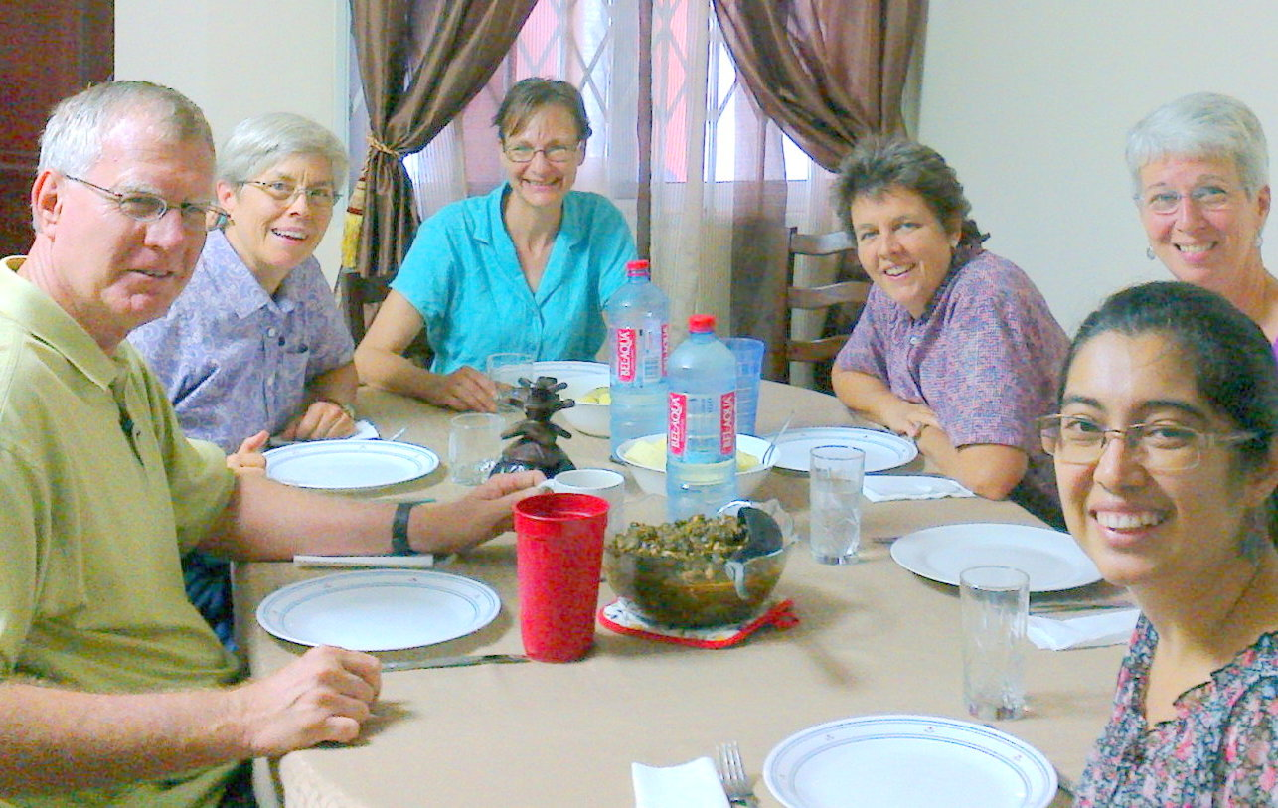
Left to right: Patrick Schmidt (West Africa Regional Coordinator), Darlene Jerome (International MMCT), Deb Bergen (consulting psychiatrist), Karen Carr (International Team), Sue Schmidt (Administrator/Trainer) and Vivian Ochoa (Counselor/Trainer).

Feb 24: Deb lives on the seminary campus where her husband, Wes, teaches pastors of African Instituted Churches. Pray for safety and patience as she travels between these communities.

Feb 25: Darlene and Karen supervise all MMCT. Pray for their preparation of upcoming International Governing Board meetings.

Feb 26: Vivian grew up in Guatemala. She is translating culturally appropriate resources into Spanish. Pray for her work among the growing number of missionaries coming from Spanish-speaking countries.

Feb 27: Patrick and Sue provided education and administration for Wycliffe translators in West Africa for years before joining MMCT to fill roles of Regional Coordinator, trainer, counselor, logistics and finance point person, office hosts, etc. Pray for their health and stamina in these roles.

Feb 28: Togo shares Ghana’s eastern border; elections are expected but those in power are delaying. East of Togo is Benin, where the voodoo religion remains powerful. French is the official language of both, but inland jungles and mountains contain many other language groups. Pray that God’s power be seen.

Mar 1: Praise for all who brought translation and literacy to West Africa. Consider sharing prayers in Spanish, French, or other languages and appreciate the new perspective.

Mar 2: Easier travel and changed development models have increased visits by administrators and service workers. We hear a call for help with cross-culture communication, especially around expectations. Pray for understanding.

Mar 3: Pray for African staff employed by North American offices, translating cultures on both sides.

Mar 4: MMCT supports “hubs” in several countries, locally organized gatherings to build up the culture of personnel care. Ghana’s hub has taken shape in the last six months. Pray for the planners, that these meetings become fountains of refreshment rather than burdens.

Mar 5: Pray for workers in Africa who host visiting groups. Where it takes days to arrange visas and transportation, translators are few, and resources to guide adjustment are scarce, the time required can feel like a conflict with local work.

Mar 6: Cote d’Ivoire was the birthplace of MMCT at a time when many missions and businesses had headquarters there. During civil unrest MMCT and many others evacuated; few returned. Pray for the church there.

Mar 7: Local families generously welcome us to experience their cultures. Pray that their sacrifices be blessed in return.

Mar 8: Praise for what unifies the global church.

Mar 9: We hear calls to return to areas isolated by Ebola. Pray for wisdom, efficiency, and supports.

Mar 10: Liberia: Health care, roads, education, communication technology and trust between groups had not yet caught up from civil war. Pray for eradication of Ebola soon so that resources can go to other needs.

Mar 11: Sierra Leone: Core medical staff died with Ebola, and hundreds of international volunteers have stepped into gaps. Pray for the safety of all health workers, for new staff to fill vacancies, and healing of the social and emotional disruptions experienced.

Mar 12: A crucial part of MMCT’s presence is the training and support of peer crisis responders. Vivian coordinates this network, and throughout the epidemic answered requests from teams needing to evacuate and debrief, as well as individual workers affected. Pray for comfort and wisdom for all.

Mar 13: Guinea: Ebola ground zero, ravished by war. In fearful, isolated villages health teams are attacked. Pray for resources to ease the trauma and restore infrastructure.

Mar 14: Gambia and Guinea Bissau border on the Ebola epidemic but have been spared. Pray for continued vigilance and control, and for the election planned for Guinea Bissau this weekend.

Mar 15: Inspired by the vibrant colors and music of Senegal’s multicultural heritage, give praise that Ebola’s control could be demonstrated here, and pray for the workers in this rugged, beautiful country.

Mar 16: We hear the call to support families of international church workers; pray for God’s grace and love to flow through us.

Mar 17: “Third Culture Kids” (living between “passport country” and country of parents’ work) face diverse international expectations in social settings, possible colleges, and work options. We help with understanding learning needs and adjustment issues. Pray for this group of creative young people.

Mar 18: Families help care for orphans. Pray for strong hearts for all involved, whether workers remain unofficial sponsors or officially adopt. Racism in “home” countries is particularly challenging for children in transition; pray for sensitive and healthy support.

Mar 19: MMCT offers brief intensive therapy for families in crisis. Pray for the counselors and clients as we lean on God’s sustaining care and energy.

Mar 20: Each of our team members has close family on the other side of the Atlantic. Pray for the comfort of these parents and children who feel a loss they did not choose. Pray for us as we ache to share their burdens and joys.

Mar 21: Let your hands carry your prayers: send a note (and maybe a special treat) to an “at home” family member of a missionary.

Mar 22: Praise with and pray for the mixed-culture couples who are finding joy in creating family.

Mar 23: We hear the call for more member care services. Pray that workers’ needs will be met.

Mar 24: Pray for the call of those who combine a missionary heart with relevant counseling or other training. We want to heal the healers, allow teachers to learn, seek the hidden hand of God with pastors.

Mar 25: We see opportunities for our workshop on “communities of grace.” Pray that it nurtures seeds of resilience.

Mar 26: Pray that Africans interested in advanced training will find the support they need; African workers will benefit from cultural understanding beyond what foreigners can offer.

Mar 27: Sometimes money equals time: finances allow for purchasing more reliable equipment, transport, or help. Pray for wise stewardship.
Mar 28: Pray for sending mission areas to see the need for worker care, to acknowledge the emotional cost of working amidst fear and loss, to see that this is also part of God’s work on earth.

Palm Sunday: Jesus scrambled typical images of power, enjoying satire and honoring voices of children while soldiers and religious leaders watched. This week we pray for his followers in Nigeria. May their courageous witness lead to opened eyes and hearts.

Mar 30: We hear the call for intercession on behalf of northern Nigeria, terrorized by Boko Haram. Pray for wisdom for church leaders who have to decide whether closing programs removes targets or just leaves people more vulnerable. Pray for those keeping in touch with scattered congregations.

Mar 31: Easter weekend means “conference” for many African churches. Pray for safety in travel and gathering.

Apr 1: Pray for kidnapped youth and their families, and for those with the power to set them free. For those who escape, pray that healing resources will be available.

Apr 2: We remember Christ’s Last Supper. Pray for the churches that have taken in recurrent tides of refugees. Find a way to share food and drink with the broken body of Christ’s church.

Apr 3: Even on the cross Christ shows compassion to a murderer beside him, his grieving mother and a beloved friend. Pray for those who choose to remain in threatened villages to care for neighbors, and for loved ones of the martyred.

Apr 4: Disciples hide. Women prepare burial materials. The grave is guarded. Christ experiences painful death and “descends to the captives.” We wait, knowing the temporary power of death and fear.

Apr 5: If Christ is Risen, what can limit our hope? Praise with joy and expectation for West Africa.

